**France Respiratory Devices Market**

According to Intelli, the France Respiratory Devices Market size was valued at approximately USD 1,600 million in 2024 and is projected to reach USD 2327.968 million at a compound annual growth rate (CAGR) of 5.7 % over the forecast period from 2024 to 2032.

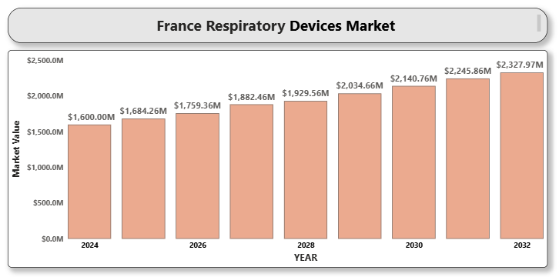

Respiratory devices are essential medical devices used to aid patients with breathing disorders, such as asthma, chronic obstructive pulmonary disease (COPD), and sleep apnea. These devices include nebulizers, oxygen concentrators, continuous positive airway pressure (CPAP) devices, and ventilators. The demand for respiratory devices is rising due to an increasing incidence of respiratory diseases, especially among the aging population, and the growing prevalence of lifestyle-related diseases such as smoking-induced COPD. Furthermore, technological advancements in the design and functionality of respiratory devices have played a major role in boosting the market growth.

**France Respiratory Devices Market Definition**

Respiratory devices are medical equipment used for diagnosing, monitoring, and treating respiratory conditions. These devices help patients breathe more easily by delivering supplemental oxygen, assisting with ventilation, or managing airflow during sleep. Key devices in this market include portable oxygen concentrators, CPAP devices, nebulizers, and mechanical ventilators. The development of advanced features such as portability, connectivity, and user-friendly interfaces has enhanced the patient experience and broadened the application of respiratory devices.

**France Respiratory Devices Market Overview**

The French respiratory devices market is seeing a shift towards home healthcare solutions, driven by the growing preference for home-based treatment options and the increasing prevalence of chronic respiratory diseases. In particular, demand for portable oxygen concentrators and CPAP devices are witnessing steady growth. France’s healthcare system, which focuses on high-quality care and improving the overall patient experience, contributes to the adoption of advanced respiratory devices. Market growth is further supported by increased government healthcare spending and the rising number of healthcare facilities offering respiratory care.

**France Respiratory Devices Market Segmentation Analysis**

The France Respiratory Devices Market is segmented based on Product Type, Application, End-user, and Geography.

**France Respiratory Devices Market By Product Type**:

• Oxygen Concentrators

• Nebulizers

• CPAP Devices

• Ventilators

• Others

Oxygen concentrators represent the largest market share due to their wide usage in home healthcare and hospitals for patients with chronic respiratory diseases. CPAP devices are also expected to grow at the fastest CAGR, attributed to the increasing prevalence of sleep apnea.

**France Respiratory Devices Market By Application**:

• Chronic Obstructive Pulmonary Disease (COPD)

• Sleep Apnea

• Asthma

• Other Respiratory Disorders

COPD remains the dominant application segment due to the high smoking rates in France, contributing to a growing patient pool. The sleep apnea segment is expected to expand rapidly as awareness of the condition increases.

**France Respiratory Devices Market By End-user:**

• Hospitals

• Homecare Settings

• Specialty Clinics

Hospitals dominate the market due to the high usage of advanced respiratory devices in emergency and intensive care units. However, homecare settings are expected to grow at a significant rate, driven by an aging population and an increasing preference for home-based treatments.

**France Respiratory Devices Market, By Region:**

• Paris

• Lyon

• Marseille

• Toulouse

• Others

Paris is the largest market for respiratory devices, owing to its highly developed healthcare infrastructure and dense population.

**Key Players**

Major players in the France Respiratory Devices Market include Philips Healthcare, ResMed Inc., Medtronic PLC, Fisher & Paykel Healthcare, Invacare Corporation, and BD (Becton Dickinson and Company). These companies focus on product innovation and strategic collaborations to strengthen their position in the market.

**Key Developments**

• ResMed launched a new version of its AirSense 11 CPAP machine in 2024, featuring a more user-friendly interface and improved connectivity to track sleep data for patients.

• Philips Healthcare introduced its Dream Station 2 CPAP in 2024, designed to provide enhanced sleep apnea treatment with quieter operation and improved comfort.

• Medtronic unveiled the LivaNova Ventilator in early 2024, aimed at offering a reliable and cost-effective ventilator solution for hospitals and homecare settings.

**Market Attractiveness**

The market attractiveness in France is enhanced by the government’s initiatives to improve respiratory care facilities and the increasing demand for homecare solutions. The healthcare reforms and the growing healthcare expenditure contribute to a favorable market environment.

**Porter’s Five Forces**

Porter’s Five Forces analysis reveals moderate to high competition in the France Respiratory Devices Market, with strong bargaining power from buyers and suppliers due to the availability of numerous advanced and cost-effective respiratory products. Rivalry among major players is intense, and new entrants face high barriers to entry due to regulatory approvals and established brand loyalty.

**TABLE OF CONTENT**

**1. INTRODUCTION OF FRANCE RESPIRATORY DEVICES MARKET**

1.1 Overview of the Market

1.2 Scope of Report

1.3 Assumptions

**2. EXECUTIVE SUMMARY**

**3. RESEARCH METHODOLOGY 3.1 Data Mining**

3.2 Validation

3.3 Primary Interviews

List of Data Sources

**4. FRANCE RESPIRATORY DEVICES MARKET OUTLOOK 4.1 Overview**

4.2 Market Dynamics

4.3 Drivers

4.4 Restraints

4.5 Opportunities

4.6 Trends

4.7 Porter's Five Force Model

4.8 Value Chain Analysis

**5. FRANCE RESPIRATORY DEVICES MARKET, BY PRODUCT TYPE**

5.1 Overview

5.2 Oxygen Concentrators

5.3 Nebulizers

5.4 CPAP Devices

5.5 Ventilators

5.6 Others

**6. FRANCE RESPIRATORY DEVICES MARKET, BY APPLICATION**

6.1 Overview

6.2 COPD

6.3 Sleep Apnea

6.4 Asthma

6.5 Other Respiratory Disorders

**7. FRANCE RESPIRATORY DEVICES MARKET, BY END-USER**

7.1 Overview

7.2 Hospitals

7.3 Homecare Settings

7.4 Specialty Clinics

**8. FRANCE RESPIRATORY DEVICES MARKET, BY REGION**

8.1 Overview

8.2 Paris

8.3 Lyon

8.4 Marseille

8.5 Toulouse

8.6 Others

**9. FRANCE RESPIRATORY DEVICES MARKET COMPETITIVE LANDSCAPE**

9.1 Overview

9.2 Company Market Ranking

9.3 Key Development Strategies

**10. COMPANY PROFILES**

* 1. **Philips Healthcare**

### Overview

### Financial Performance

### Product Outlook

### Key Developments

* 1. **ResMed Inc.**

### A close-up of hands holding a tablet and a pen Description automatically generatedOverview

### Financial Performance

### Product Outlook

### Key Developments

* 1. **Medtronic PLC**

### Overview

### Financial Performance

### Product Outlook

### Key Developments

* 1. **Fisher & Paykel Healthcare**

### A close-up of hands holding a tablet and a pen Description automatically generatedOverview

### Financial Performance

### Product Outlook

### Key Developments

* 1. **Invacare Corporation**

### Overview

### Financial Performance

### Product Outlook

### Key Developments

* 1. **BD (Becton Dickinson and Company)**

### Overview

### Financial Performance

### Product Outlook

### Key Developments

**11. KEY DEVELOPMENTS**

* Product Launches/Developments
* Mergers and Acquisitions
* Business Expansions
* Partnerships and Collaborations

**12. APPENDIX**

12.1 Related Research